1. Project Overview

To implement a processing system which accepts log files as input and returns the log files with line numbers in each file based on the timestamp of the log files.

2. Workflow Diagram

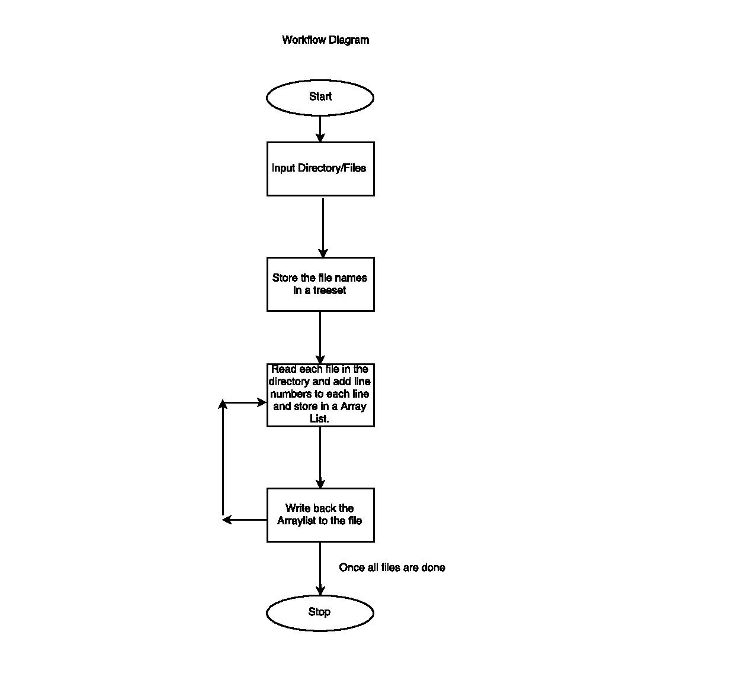

**3. Technical Specifications**

All the development is done using Java 1.8 with Gradle and Junit.

4. Coding Considerations

- First the list of files are loaded into a TreeSet so that they will be sorted based on the names. By doing this we can be sure that the files are arranged according to the timestamp as the file names assumed to be are “Log_2015_06_03.log.

- After we store the files in the TreeSet we send each file to a function appendLineNumbers which will read each file name from the TreeSet and call appendLineNumbersToEachFileContent.

- This function will read the file and copy the contents of each line as a member of a ArrayList by concatenating it with the line number and returns the List.

- Once this is done appendLineNumbers will make a call to writeToFile which will accept this Arraylist and file name and will perform the writing.

5. Revision History

|  |  |  |  |
| --- | --- | --- | --- |
| **Revision** | **Date** | **Name** | **Description of Change** |
| 1 | 12/31/2015 | Sudhaker V Manikonda | Initial release |